Requirement Analysis Phase Template
Technology Stack.
DATE: | 27/09/2026
TEAM ID: | SWTID-2026-6463
PROJECT NAME: | AI FAQ Assistant API
MAXIMUM MARKS: | 4 Marks

Technical Architecture:
The Deliverable shall include the architectural diagram as below and the information as per the table1 & table 2
Example: Order processing during pandemics for offline mode
Reference: https://developer.ibm.com/patterns/ai-powered-backend-system-for-order-processing-during-pandemics/
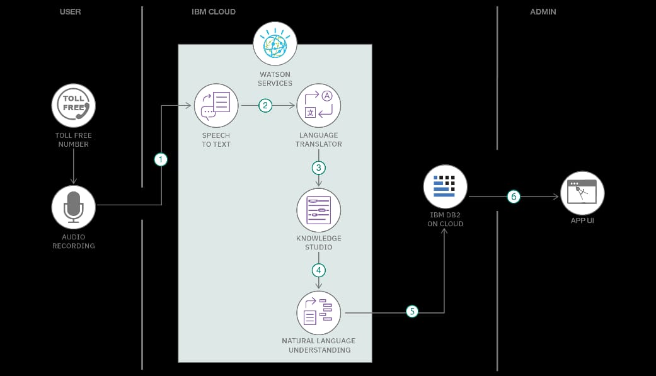

Guidelines:

Include all the processes (As an application logic / Technology Block)
Provide infrastructural demarcation (Local / Cloud)
Indicate external interfaces (third party API's etc.) Indicate Data Storage components / services Indicate interface to machine learning models (if applicable)

Table 1: Components & Technologies.
S.No | Component | Description | Technology
1 | User Interface | User registration, login,  FAQ search and Al  Library  answers. | HTML, JavaScript
2 | Application  Logic-1 | User registration, login  and authentication. | Node.js,  Express.js, JWT,  bcryptjs
3 | Application Logic-2 | Create, view, update and delete FAQs. | Node.js, Express.js
4 | Application Logic-3 | Generate Al answers and topic suggestions. | Google Gemini API
5 | Database | Store user details and FAQ records. | MongoDB, Mongoose
6 | Cloud Database | Store application data online, if used. | MongoDB Atlas

Table 2: Application Characteristics
S.No | Characteristics | Description | Technology
1 | Open-Source Frameworks | Uses open-source frameworks for frontend, backend  and database operations. | Express.js, Node.js, MongoDB
2 | Security Implementations | Uses password hashing, JWT authentication and protected routes. | bcryptjs, JWT, HTTP
3 | Scalable Architecture | Modular REST API architecture supports adding more users and FAQs. | Node.js, Express.js, MongoDB
4 | Availability | Provides access to published FAQs and AI-assisted answers through the application. | Node.js Server / Cloud Hosting
5 | Performance | Uses database queries and semantic search to retrieve relevant FAQs and generate answers. | MongoDB, Mongoose, Google Gemini API

